PROJECT REPORT

ON

**The Finite Element Method/Finite difference methods in Electromagnetism**

By

**C Pranay Reddy -** 2014B4A80757P

**Rasal Kumar -** 2014B4A80801P

Prepared in complete fulfillment of the

MATH F376(Design Project) submitted to

**Dr. Sangita Yadav**



BIRLA INSTITUTE OF TECHNOLOGY AND SCIENCE,PILANI

**Acknowledgements**

We would like to thank our Vice-Chancellor, Prof. Souvik Bhattacharya and HoD, Department of Mathematics, BITS Pilani Pilani Campus, Dr. Balram Dubey for giving us an opportunity to enroll in the course on Design Project in Mathematics(MATH F376), so that we could study the topic of my interest in BITS. We express special gratitude to Dr. Sangita Yadav for her relentless efforts in guiding us, so that the topic is clearly understood by us and making us thorough with the knowledge leaving no stone unturned so that we could implement the theory in practical world.

**Abstract**

The project aims to study the application and use of finite element method and finite difference methods in electromagnetism. Electromagnetism is one of the evolving fields of science with various applications in real life. We consider some of these problems in this project.

­­­­­­­­­­

## Introduction

We know the methods like Bisection method, Secant method, Newton Raphson method to find the root of an equation. But when the equation includes a differential operator i.e. a differential equation the known numerical solution methods are Picards method, Runge kutta method etc.

For a better solution i.e. for an approximated solution with lesser error we use various collocation methods. Hence a numerical method is being used in this project.

Here in this contest of study, we considered two problems in electromagnetism. The first problem involves the problem of finding electric field on a parallel plate capacitor with a dielectric slab which involves one dimensional Poisson's equation. The second problem involves the calculation of electric field on a Cylindrical surface involving the use of three dimensional Poisson Equation using polar coordinates.

The work done till mid semester was based on the complete solution of one dimensional parallel plate capacitor problem and illustration of how to solve 2 dimensional Poisson equation using finite element method. Then, we concentrated on solving the electromagnetic equations using finite difference methods

The project in the initial phase was aimed at solving the two problems using finite element method and show the error between the finite element solutions and the exact solutions. Then, all types of PDE's have been solved in the matlab.

# **Electric Potential in a parallel plate Capacitor**

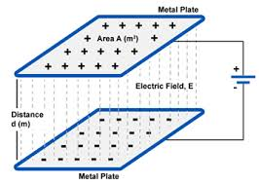





# **Dielectric Slab in a Capacitor**

# C:\Users\USER\Downloads\Dielectric slab.GIF

Steps to solve Boundary Value Problems:

* Solve the equation (Poisson / Laplace) in appropriate coordinate system.
* Apply boundary conditions.
* Calculate V.
* Use E=-Grad(V)
* D=eE and J=𝜎E

# For the capacitor problem let us consider a dielectric placed in z direction with a uniform charge density 𝜌. Therefore

# 





z = 0 , 

z = d , V = 0











Matlab Implementation:

N = [12,22,42,82];

q = 0.3*10^(6);

k = 25;

T_s = 365;

b(1,1) =0;

T1 = zeros(82,4);

T_analyical = zeros(82,4); % analytical/exact Potential matrix

for i = 1:4

a =[0,1,-1,1,-2,1,0,1,0,N(1,i)];

% matrix of coefficients

b(N(1,i),1) = T_s;

b(2:(N(1,i)-1),1) = (-q/k)*((0.1/(N(1,i)-1))^(2));

TDM = tridiagonal_mat(a);

[B,A] = res_mat(b,TDM);

T = TDM_sol(B,A);

T(1,1) = T(2,1);

T1(1:N(1,i),i) = T(:,1);

% Potential values calculated using TDM with different grid sizes.

T_analytical(1:N(1,i),i) = T_exact(T_s,N(1,i));

% exact potential values with different grid sizes

Error(1:N(1,i),i) = T_analytical(1:N(1,i),i)-T1(1:N(1,i),i);

Average_L2_Norm(1,i) = sqrt((1/(N(1,i)-1))*(sum(Error(:,i).^(2))));

end

x1 = 0:(0.1/11):0.1;

x2 = 0:(0.1/21):0.1;

x3 = 0:(0.1/41):0.1;

x4 = 0:(0.1/81):0.1;

figure % Potential Plot (both numerical and analytical)

plot(x1,T1(1:12,1),'.',x1,T_analytical(1:12,1),'.')

hold on

plot(x2,T1(1:22,2),'o',x2,T_analytical(1:22,2),'o')

hold on

plot(x3,T1(1:42,3),':',x3,T_analytical(1:42,3),':')

hold on

plot(x4,T1(1:82,4),'*',x4,T_analytical(1:82,4),'*')

figure (2) % Error Plot

plot(x1,Error(1:12,1),'.')

hold on

plot(x2,Error(1:22,2),'o')

hold on

plot(x3,Error(1:42,3),':')

hold on

plot(x4,Error(1:82,4),'*')

function [T] = TDM_sol(B,A)

N = size(B,1);

T(N,1) = B(N,1)/A(2,N);

for i = N-1:-1:2

T(i,1) = (B(i,1) - (A(3,i)*T(i+1,1)))/A(2,i); % calculating Potential matrix using Tri-diagonal matrix.

end

end

function [T_analytical] = T_exact(T_s,N)

q = 0.3*10^(6);

k = 25;

for j = 1:N

T(1,j) = T_s + (q/(2*k))*(0.01-(((0.1/(N-1))*(j-1))^2));

end

T_analytical = T;

end

function[D, L, U] = trans_mat(A)

D = diag(diag(A)); % extracting the diagonal elements of A

L = -1*tril(A,-1);

U = -1*triu(A,1);

end

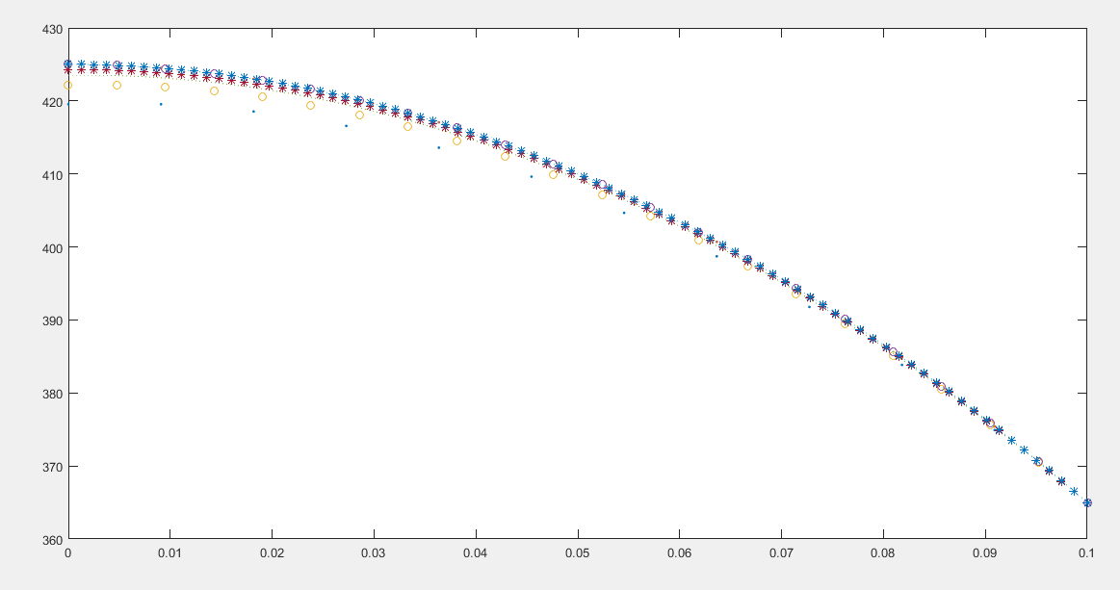

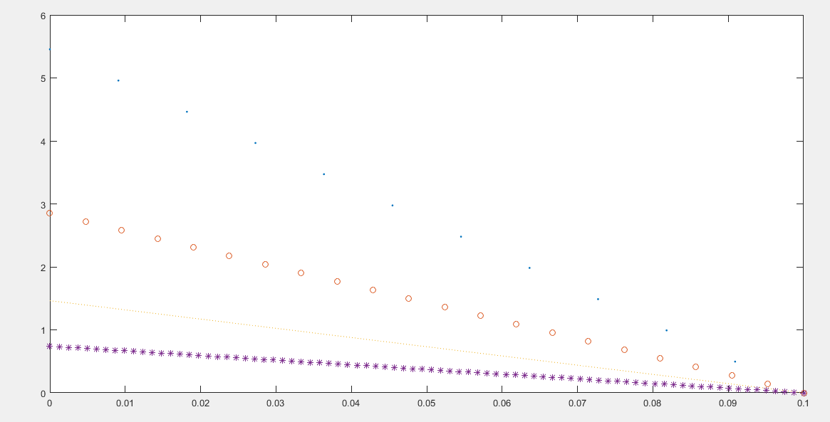

# The convergence criteria was 1e-08 (from the exact solution).

# For N=11, the number of iterations needed for convergence were 1180.

# For N=21, the number of iterations needed for convergence were 3742.

# For N=41, the number of iterations needed for convergence were 12714.

# For N=81, the number of iterations needed for convergence were 44801.

# All these results are without relaxation.

# Taking the boundary condition as first order played an important role in defining the temperature at other nodes as can be seen from the graph. As the number of grid points are increased the error decreases, this is because as the size of grid decreases the governing equation can be approximated with linear relation for closer points. But, as the governing equation is of second order, in gauss siedel it is found that the potential values converges even for coarse grid size of N = 11. But the L2-norm of the second order approximation increases because as the number of grid points increases the error gets accumulated.

# Problem for 2D Poisson Equation:

# Suppose a rectangle bar in kept on Y-axis of a coordinate system. It has length l and breadth W. Assume the charge distribution to be uniform in the bar with sigma as the constant. Assume that the centre of gravity of the rod lies at the origin. Find the electric field distribution on the X axis.

# Matlab Implementation:(Poisson)

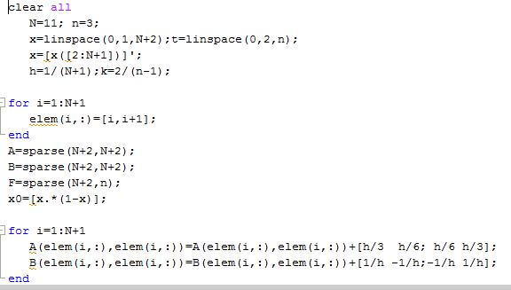

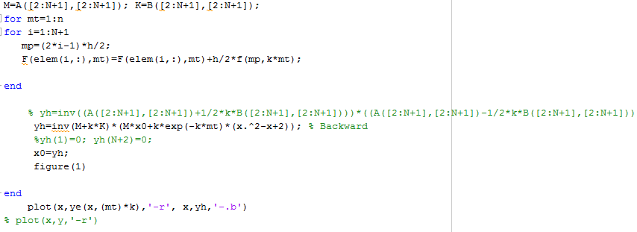

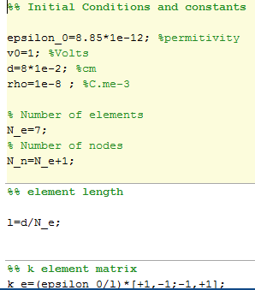

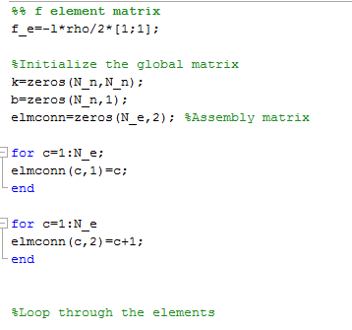

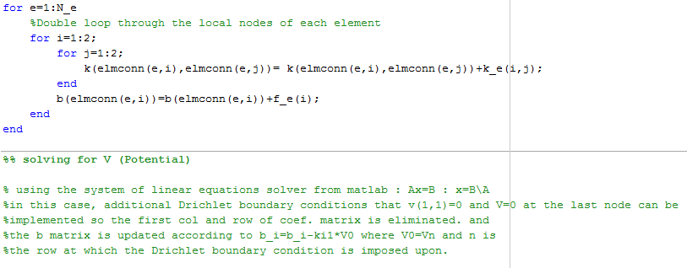

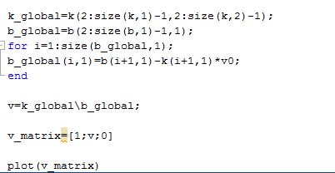

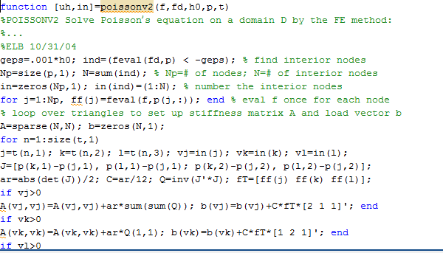

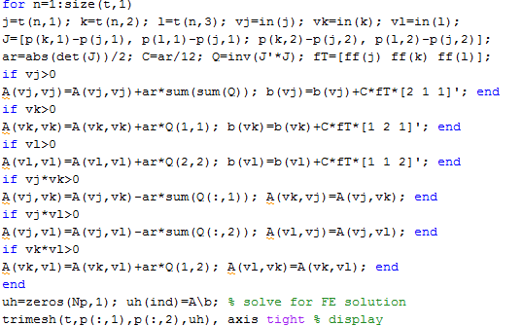

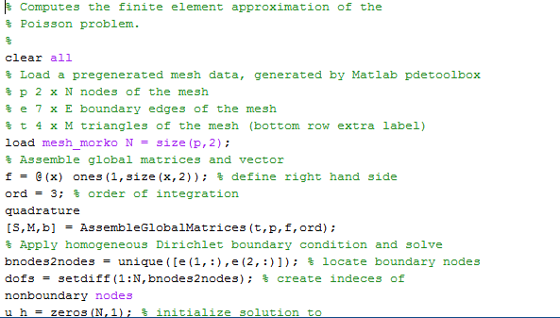

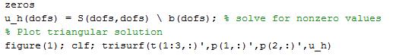

# Laplace 2D Equation:

Application: Suppose there are two concentric hollow shells with charge density +Q and -Q on them respectively. Then the net electric field at any point outside the two shells will be zero. This is because the net charge enclosed by a gaussian surface including the two rings is zero. Therefore gradient of potential will be zero which is the Laplace Equation.

# Matlab Implementation:(Laplace)

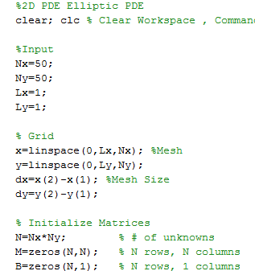

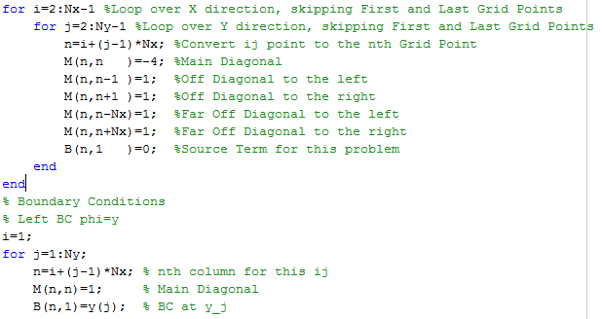

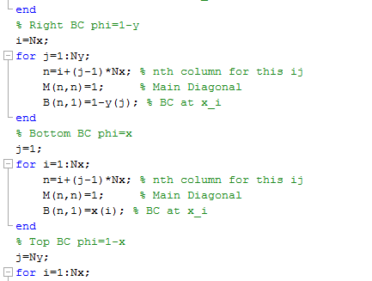

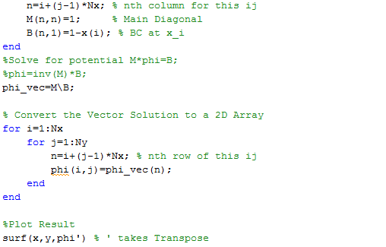

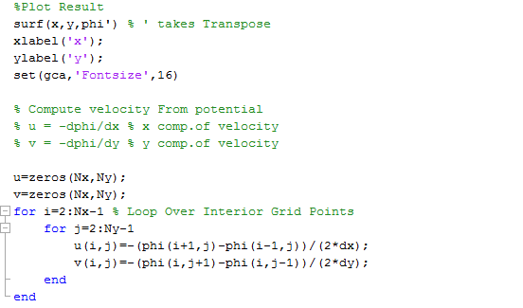

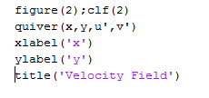

We ended up with the following results.

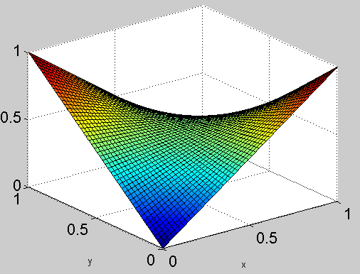

Fig. The Potential Plot.

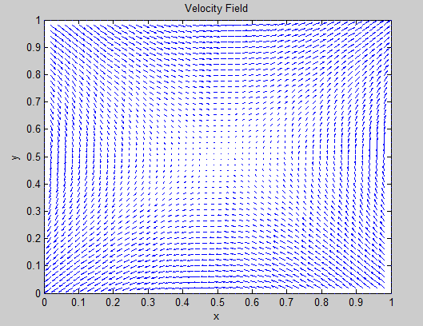

This graph can be interpreted as suppose there are two source(+ve) charges and two sink charges at (1,0) ,(0,1) and (0,0),(1,1) . The two source charges will create field lines that are going away from them and the two sink charges will have field lines that are coming towards them. There will be a NULL point(0.5,0.5) where the field lines will cancel each other resulting in the net electric field to be zero at that point. All these things are clearly visible in the graph.

Fig. The Velocity Field.

Then, we solved one more elliptic equation on the same lines.

$$u_{xx}+u_{yy}= -2π^{2}u$$

where u = 0 on boundary.

## Matlab Implementation.

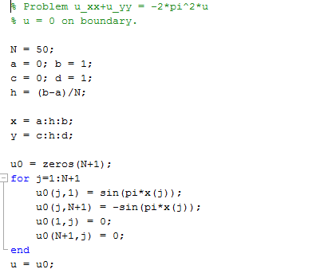

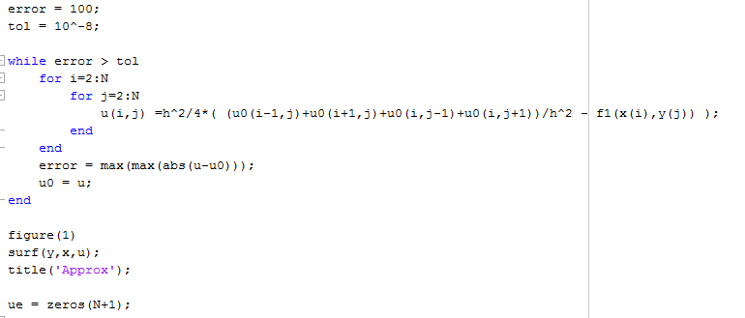

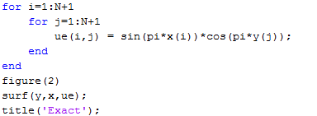

We ended up with the following results.

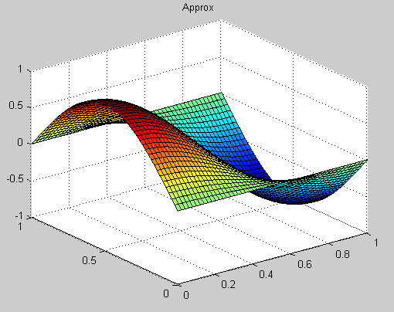

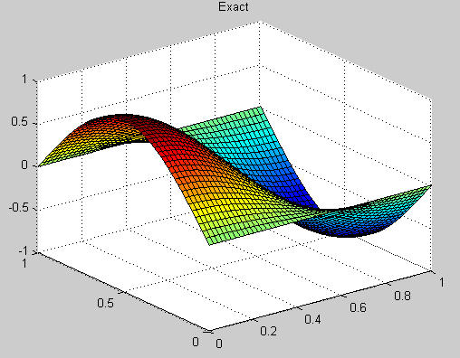

# Matlab Implementation:(Heat)

$$u_{t}=u_{xx};u\left(x,0\right)=\sin\left(πx\right);u\left(0,t\right)= 0;u\left(1,t\right)= 0$$

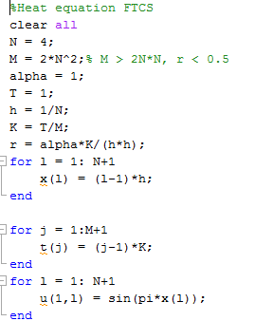

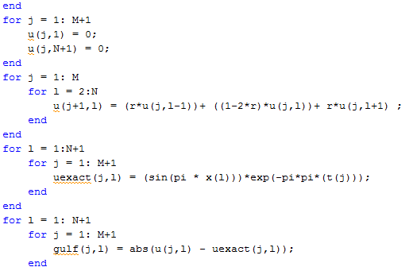

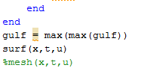

We ended up with the following results.

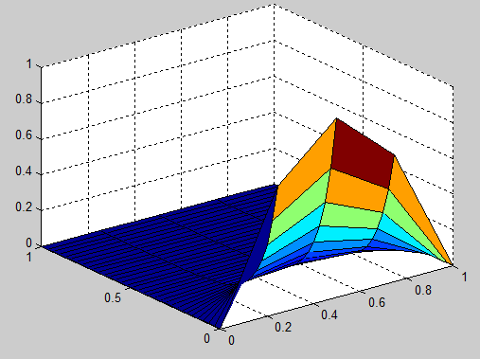

# Matlab Implementation:(Advection equation)

Problem: Suppose there is a charge moving with its velocity both along with its position coordinates and along with the time axes. Find the velocity at a particular time.

$$u_{t}= -vu_{x}$$

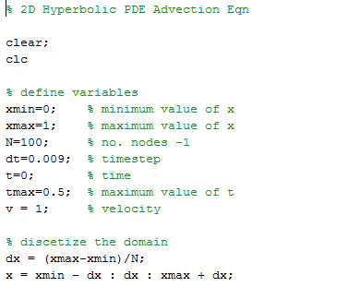

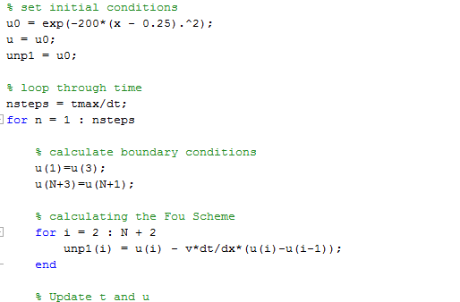

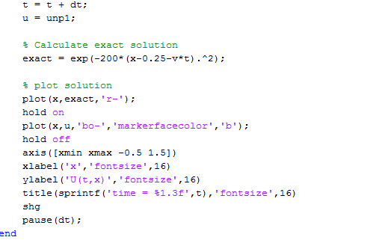

We ended up with the following results.

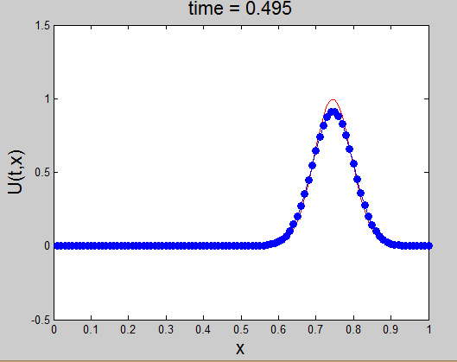

**Non linear PDE**

Let's suppose we have a non linear PDE given. Then the Tri diagonal solution wont work. We would have to discretize the PDE and then use Newton Ralpson method to calculated the values at various coordinates.









$$u_{t}+6uu_{x}+u_{xxx}=0;$$

$$u\left(x,0\right)=A.{\sec{h}}^{2}\left(Kx\right);$$

$$u\left(-20,t\right)= u\left(20,t\right)$$

-20 < x < 20; t > 0.

## Matlab Implementation.

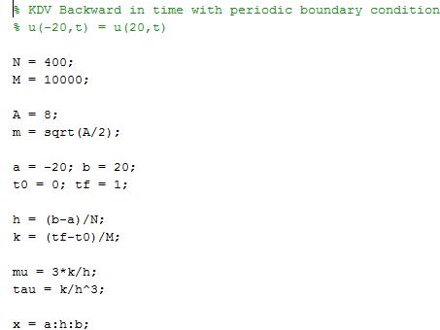

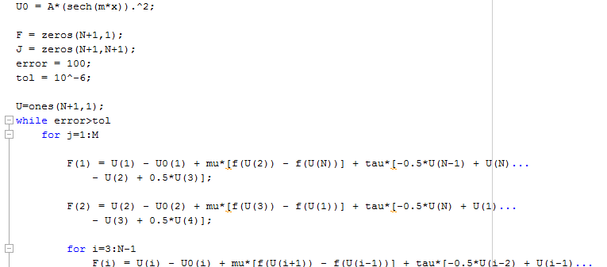

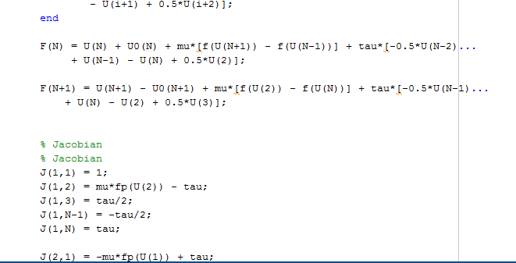

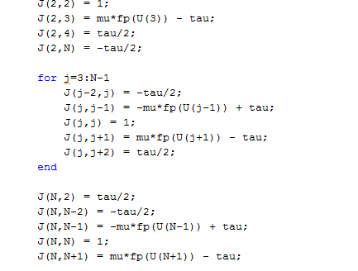

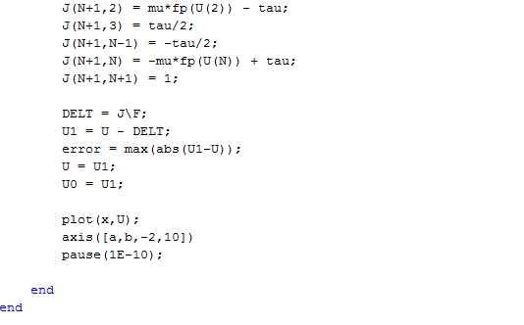

Plot is as follows.

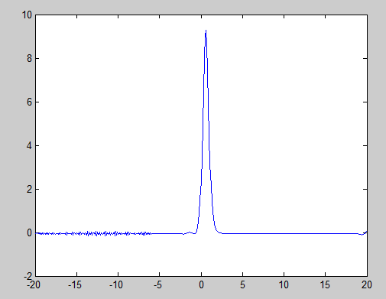

Using Crank Nicholson Scheme:







Crank Nicolson with periodic boundary condition

% u(-20,t) = u(20,t)

N = 200;

M = 1000;

A = 10;

m = sqrt(A/2);

a = -20; b = 20;

t0 = 0; tf = 1;

h = (b-a)/N;

k = (tf-t0)/M;

mu = 6*k/(4*h);

tau = k/(4*h^3);

x = a:h:b;

u0 = A*(sech(m*x)).^2;

F = zeros(N+1,1);

J = zeros(N+1);

error = 100;

tol = 10^-6;

U = ones(N+1,1);

while error > tol

for p=1:M

F(1) = U(1) - u0(1) + mu*(f(U(2))-f(U(N)) + f(u0(2))-f(u0(N))) + ...

tau*(U(3)-2*U(2)+2*U(N)-U(N-1) + u0(3)-2*u0(2)+2*u0(N)-u0(N-1));

F(2) = U(2) - u0(2) + mu*(f(U(3))-f(U(1)) + f(u0(3))-f(u0(1))) + ...

tau*(U(4)-2*U(3)+2*U(1)-U(N) + u0(4)-2*u0(3)+2*u0(1)-u0(N));

F(N) = U(N) - u0(N) + mu*(f(U(N+1))-f(U(N-1)) + f(u0(N+1))-f(u0(N-1))) + ...

tau*(U(2)-2*U(N+1)+2*U(N-1)-U(N-2) + u0(2)-2*u0(N+1)+2*u0(N-1)-u0(N-2));

F(N+1) = U(N+1) - u0(N+1) + mu*(f(U(2))-f(U(N)) + f(u0(2))-f(u0(N))) + ...

tau*(U(3)-2*U(2)+2*U(N)-U(N-1) + u0(3)-2*u0(2)+2*u0(N)-u0(N-1));

for j=3:N-1

F(j) = U(j) - u0(j) + mu*(f(U(j+1))-f(U(j-1)) + f(u0(j+1))-f(u0(j-1))) + ...

tau*(U(j+2)-2*U(j+1)+2*U(j-1)-U(j-2) + u0(j+2)-2*u0(j+1)+2*u0(j-1)-u0(j-2));

end

% Jacobian

% Jacobian

J(1,1) = 1;

J(1,2) = mu*df(U(2)) - 2*tau;

J(1,3) = tau;

J(1,N-1) = -tau;

J(1,N) = -mu*df(U(N))+2*tau;

J(2,1) = -mu*df(U(1)) + 2*tau;

J(2,2) = 1;

J(2,3) = mu*df(U(3)) - 2*tau;

J(2,4) = tau;

J(2,N) = -tau;

for j=3:N-1

J(j,j) = 1;

J(j,j+2) = tau;

J(j,j-2) = -tau;

J(j-1,j) = mu*df(U(j))-2*tau;

J(j,j-1) = -mu*df(U(j-1))+2*tau;

end

J(N,2) = tau;

J(N,N-1) = -mu*df(U(N-1))+2*tau;

J(N,N) = 1;

J(N,N-2) = -tau;

J(N,N+1) = mu*df(U(N)) - 2*tau;

J(N+1,2) = mu*df(U(2))-2*tau;

J(N+1,3) = tau;

J(N+1,N-1) = -tau;

J(N+1,N) = -mu*df(U(N))+2*tau;

J(N+1,N+1) = 1;

DELT = J\F;

U2 = U - DELT;

error = max(abs(U2-U));

U = U2;

u0 = U2;

plot(x,U)

axis([a,b,-2,10])

pause(0.001)

end

end

function V = f(x)

V = x^2/2;

end

function V = df(x)

V = x;

end

Output:

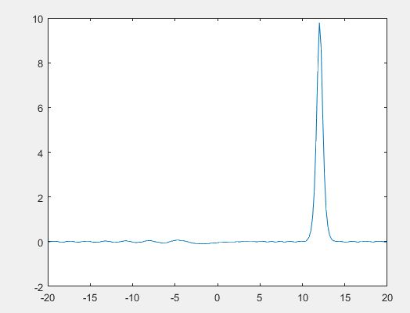

# References

**1.** R. Courant, "Variational methods for the solution of Problems of Equilibrium and vibrations", *Bull. Am. Math. Soc.*, vol. 49, 1943.

2. J. F. Hoburg, J. L. Davis, "A student-oriented finite element program for electromagnetism problems", IEEE Trans. Educ., vol. E-26, pp. 138-142, Nov. 1983.

3. The Finite Element Method in Electromagnetics, 3rd Edition

Jian-Ming Jin, Mar 2014.

4. Wikipedia

5. Www.mathworks.com

Thank You